**Capstone Project**

**Hotel Booking Analysis**

**Vaidehi Tiwari**

**Points to Discuss:**

* Agenda
* Data summary
* Univariate analysis
* Hotel wise analysis
* Distribution Channel wise analysis
* Booking cancellation analysis
* Timewise analysis
* Some important questions
* Correlation heatmap
* Conclusion

# Agenda

To discuss the analysis of given hotel bookings data set from 2015-2017.

We’ll be doing analysis of given data set in following ways:

* Univariate analysis
* Hotel wise analysis
* Distribution Channel wise analysis
* Booking cancellation analysis
* Timewise analysis

By doing this we will try to find out key factors driving the hotel bookings trends.

## Data Summary

Given data set has different columns of variables crucial for hotel bookings. Some of them are:

hotel: The category of hotels, which are two resort hotel and city hotel.

is_cancelled : The value of column show the cancellation type. If the booking was cancelled or not. Values[0,1], where 0 indicates not cancelled.

lead_time : The time between reservation and actual arrival.

stayed_in_weekend_nights: The number of weekend nights stay per reservation stayed_in_weekday_nights: The number of weekday nights stay per reservation.

meal: Meal preferences per reservation.[BB,FB,HB,SC,Undefined] Country: The origin country of guest.

## Data Summary (contd.)

market_segment: This column show how reservation was made and what is the purpose of reservation. Eg, corporate means corporate trip, TA for travel agency.

distribution_channel: The medium through booking was made.[Direct,Corporate,TA/TO,undefined,GDS.]

Is_repeated_guest: Shows if the guest is who has arrived earlier or not.Values[0,1]-->0 indicates no and 1 indicated yes person is repeated guest. days_in_waiting_list: Number of days between actual booking and transact.

customer_type: Type of customers( Transient, group, etc.)

## Data Summary

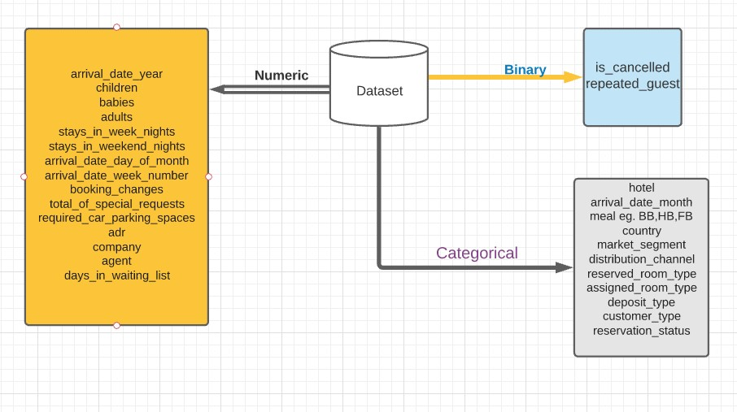

### Univariate Analysis

While doing univariate analysis of given hotel booking dataset, we answered following questions:

1. Which agent made most of bookings?
2. Which room type is in most demand and which room type generates highest adr?
3. From which country most of the customers are coming?
4. What is the most preferred meal by customers?

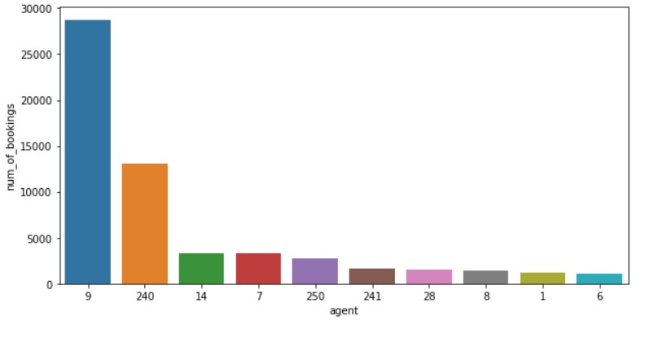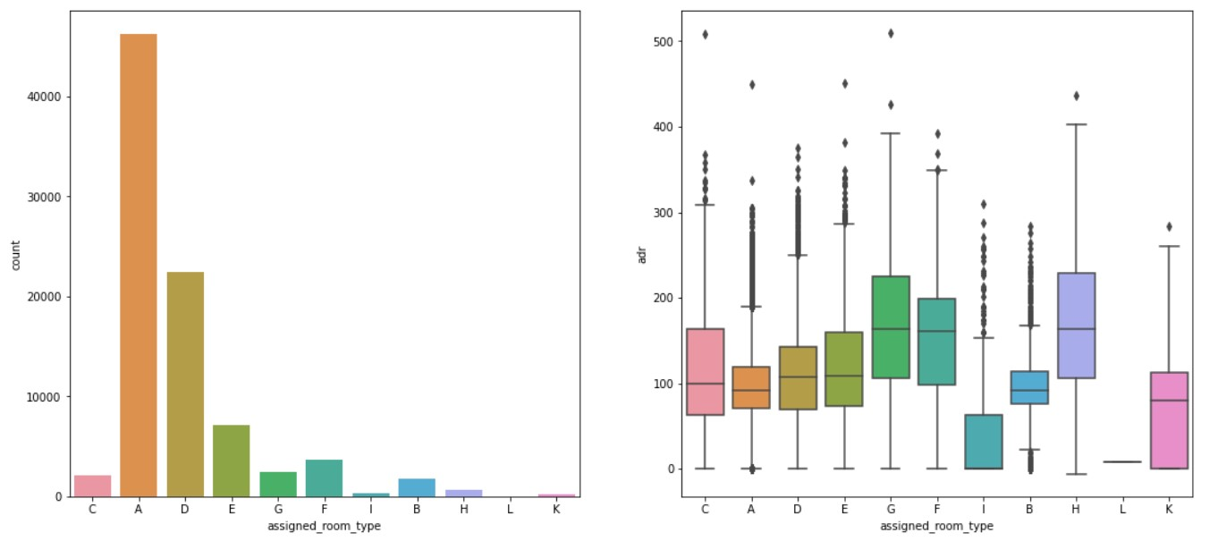

•

Type

A room is most demanded by customers.

•

Room types C, G and H are some of the highest

adr

(

average daily rate) generating rooms

.

•

Agent with id no. 9 made most of the bookings.

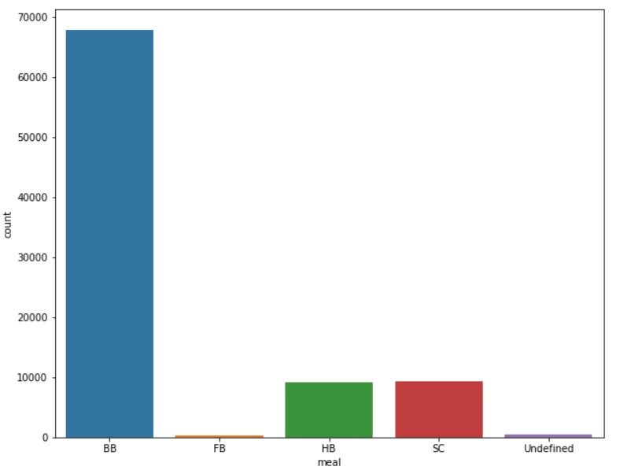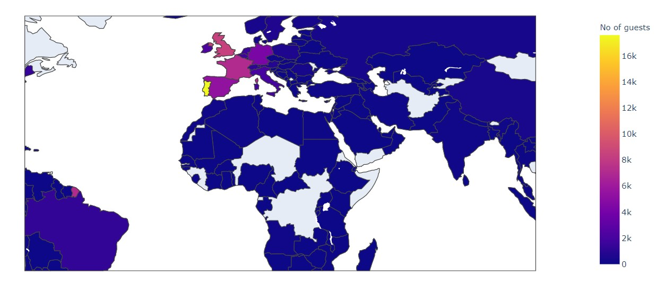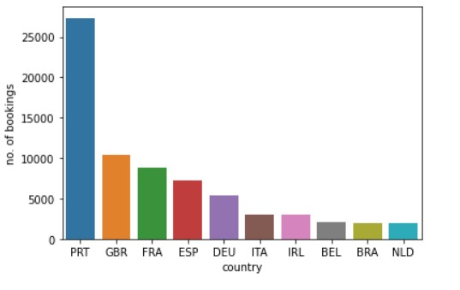

•

Most of the customers from European countries like Portugal,

Great Britain, France and Spain.

•

Most preferred meal type is BB(Bed and breakfast).

### Hotel wise Analysis

While doing hotel-wise analysis of given hotel booking dataset, we answered following questions:

1. Percentage of bookings in each hotel?
2. Which hotel makes more revenue?
3. Which hotel has higher lead time?
4. What is most preferred stay length in each hotel?
5. For which hotel, does people have to wait longer to get a booking confirmed?
6. Which hotel has higher booking cancellations rate?
7. Which hotel have higher and how much customer returning rate?

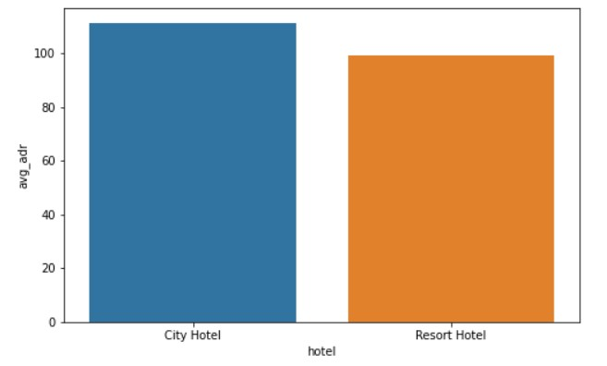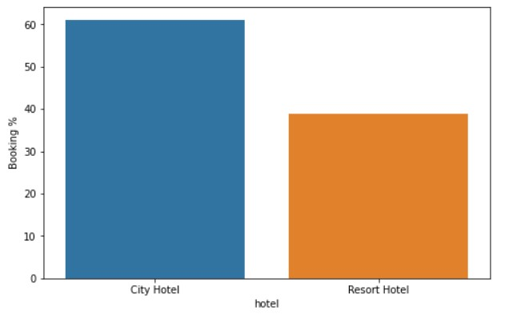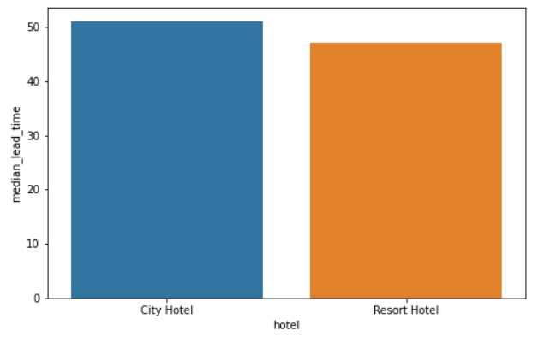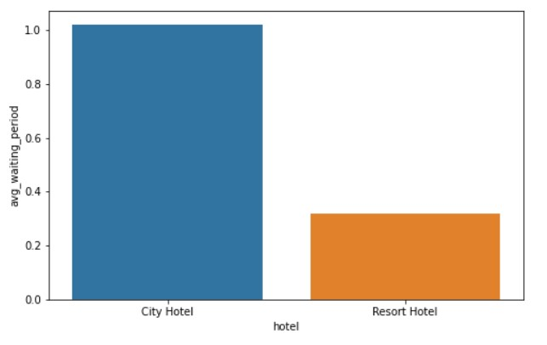

•

Around 60% bookings are for City hotel and 40% bookings are for Resort

hotel.

•

Avg adr of Resort hotel is slightly lower than that of City hotel. Hence,

City hotel seems to be making slightly more revenue.

•

City hotel has slightly higher median lead time. Also, median lead time is

significantly higher in each case, this means customers generally plan

their hotel visits way to early.

•

City hotel has significantly longer waited time, hence City Hotel is much

busier than Resort Hotel.

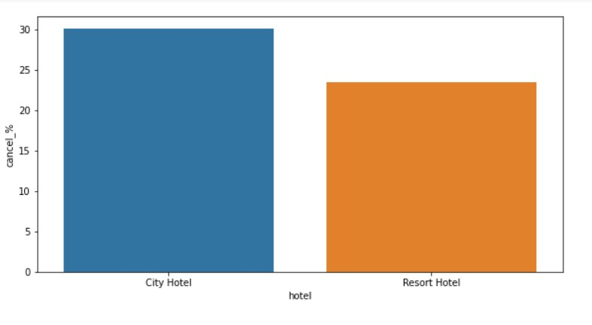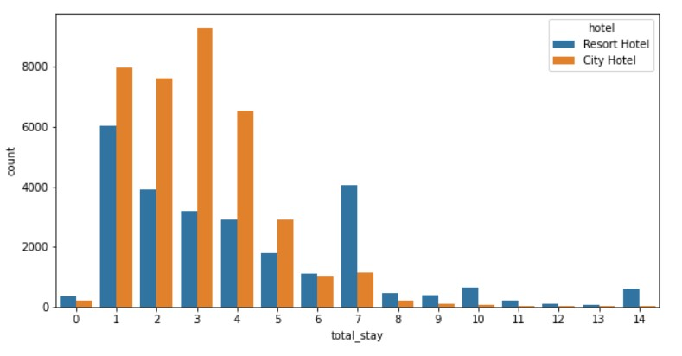

* 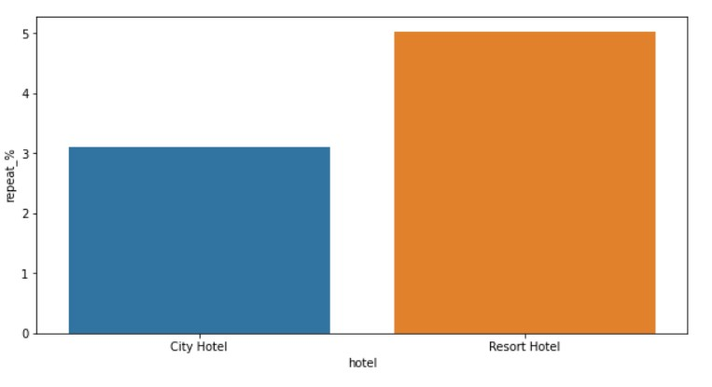Most of stays are less than 5 days. There are very few long stays at hotels but Resort Hotel is preferred for long stays.
* Almost 30 % of City Hotel bookings and 25 % of Resort hotel bookings got cancelled.
* Both hotels have very small percentage that customer will repeat, but Resort hotel has slightly higher repeat % than City Hotel.

### Distribution channel wise Analysis

While doing Distribution channel wise analysis of given hotel booking dataset, we answered following questions:

1. Which is the most common channel for booking hotels?
2. Which channel is mostly used for early booking of hotels?
3. Which distribution channel brings better revenue generating deals for hotels?

### Distribution channel wise Analysis

* 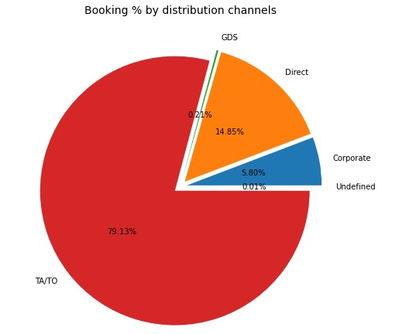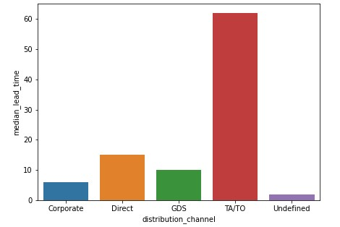Here we can see that the most of guest are making reservation through TA/TO channels which is travel agency and tour operator.
* Then the second most used channel is direct.
* Channel which is mostly used for early booking of hotels is also TA/TO.
* 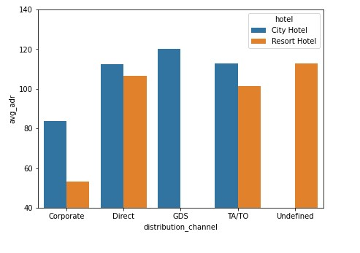GDS channel brings higher revenue generating deals for City hotel, in contrast to that most bookings come via TA/TO. City Hotel can work to increase outreach on GDS channels to get more higher revenue generating deals.
* Resort hotel has more revenue generating deals by direct and TA/TO channel. Resort Hotel need to increase outreach on GDS channel to increase revenue.

### Booking cancellation Analysis

We analyse the following possible reasons for booking cancellations:

1. Which significant distribution channel has highest cancellation percentage?
2. Longer lead time.
3. Longer time (in days) in waiting list.
4. Not getting same room as reserved.
5. Does not getting same room as reserved effects adr?

•

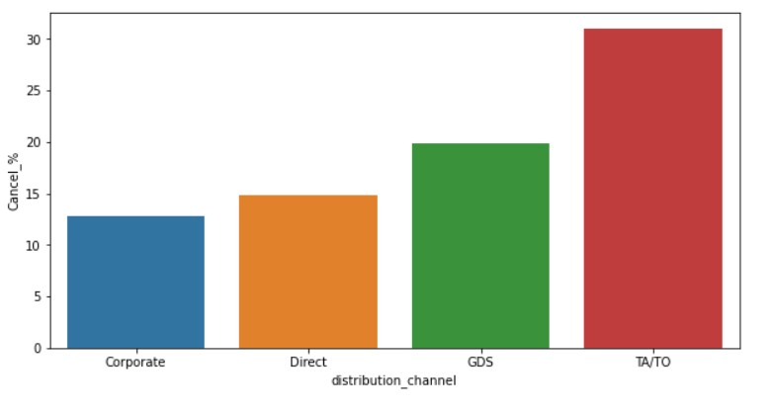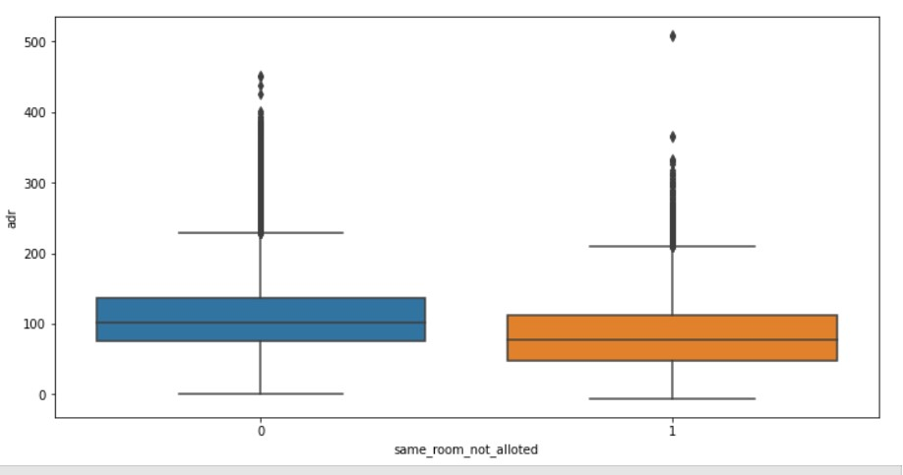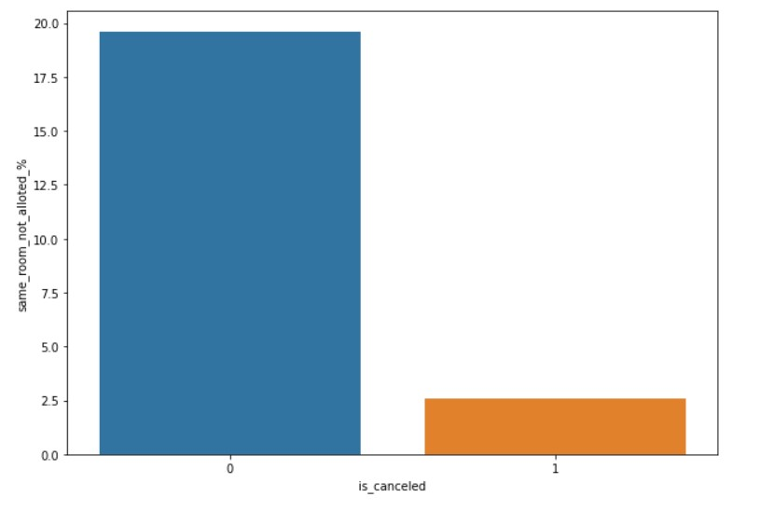

TA/TO has highest booking cancellation %. Therefore, a

booking via TA/TO is 30% likely to get cancelled.

Not getting same room as demanded is not the case of

cancellation of rooms. A significant percentage of

bookings are not cancelled even after getting different

room as demanded.

But customers who didn't got same room have paid a

little lower adr, except for few exceptions

.

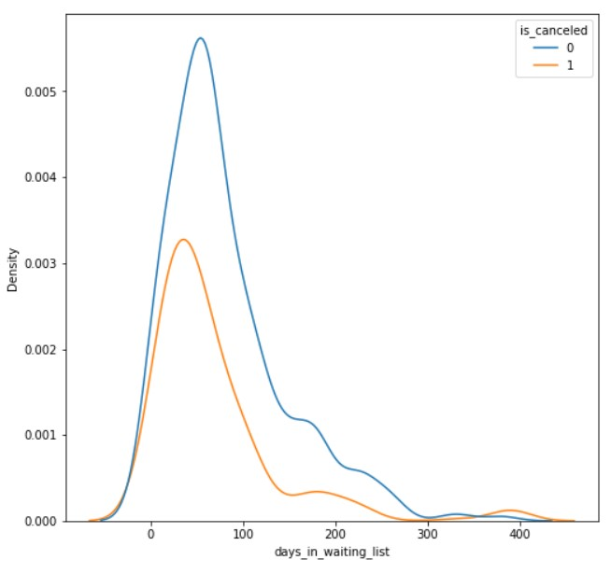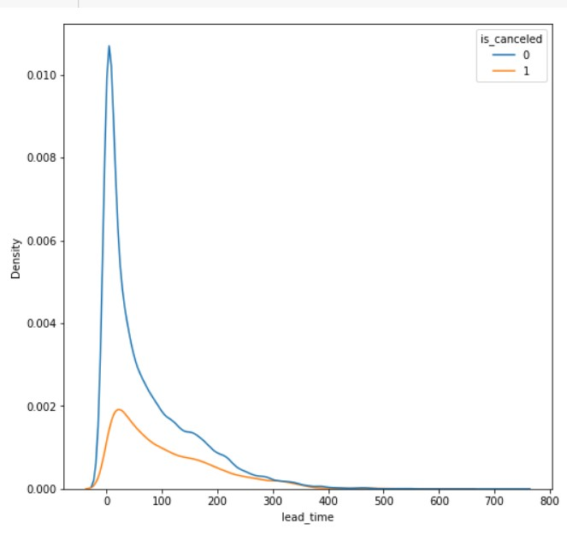

* Most of the bookings that are cancelled have waiting period of less 150 days but also most of bookings that are not cancelled also have waiting period of less than 150 days. Hence this shows that waiting period has no effect on cancellation of bookings.
* Also, lead time has no effect on cancellation of bookings, as both curves of cancellation and not cancelation are similar for lead time too.

### Time-wise Analysis

While doing time-wise analysis of given hotel booking dataset, we answered following questions:

1. What are the busiest months for hotels?
2. In which months hotels charges higher adr?
3. How does booking numbers and adr changes within a month?
4. How does bookings vary along year for different types of customers.

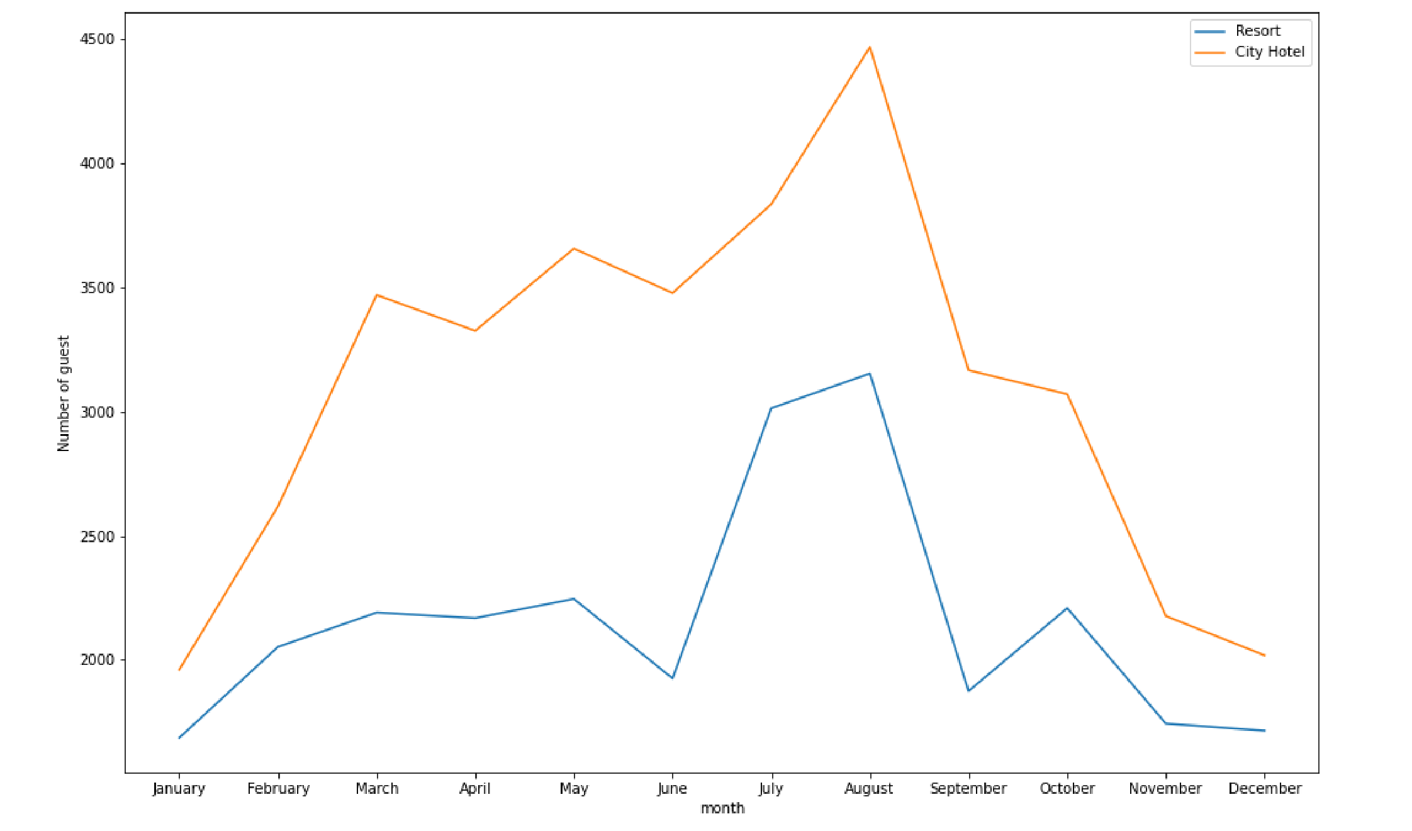From the month of July to August the number of bookings increased and in August, City Hotel got the greatest number of guests.

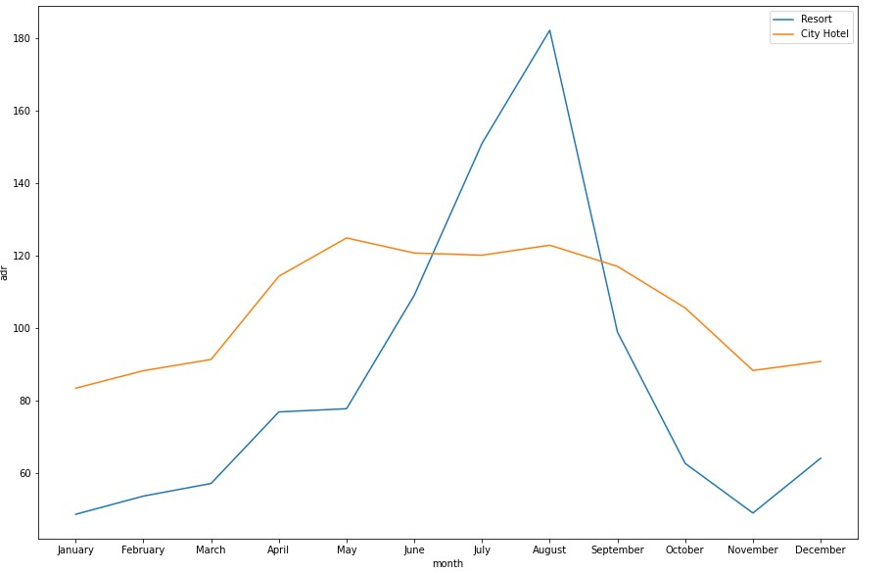The revenue aspect looks different, the Resort Hotels receives more revenue with respect to City Hotel. From May to August there was rapid increase in adr. August recorded the highest.

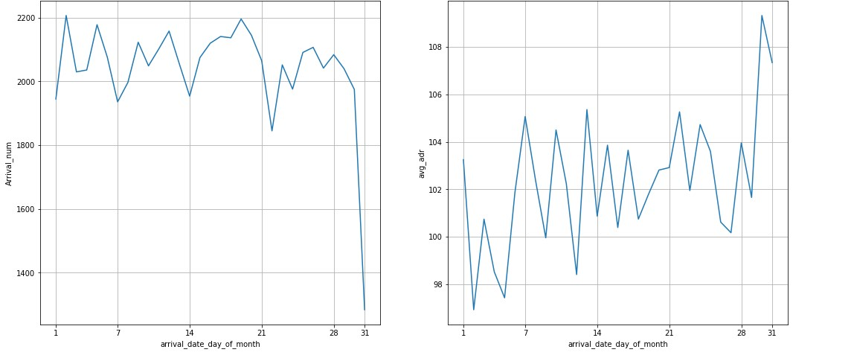

We can see that graph Arrival_num has small peaks at regular interval of days. This can be due to increase in arrival weekend.

Also, the avg adr tends to go up as month ends. Therefore, charges are more at the end of month.

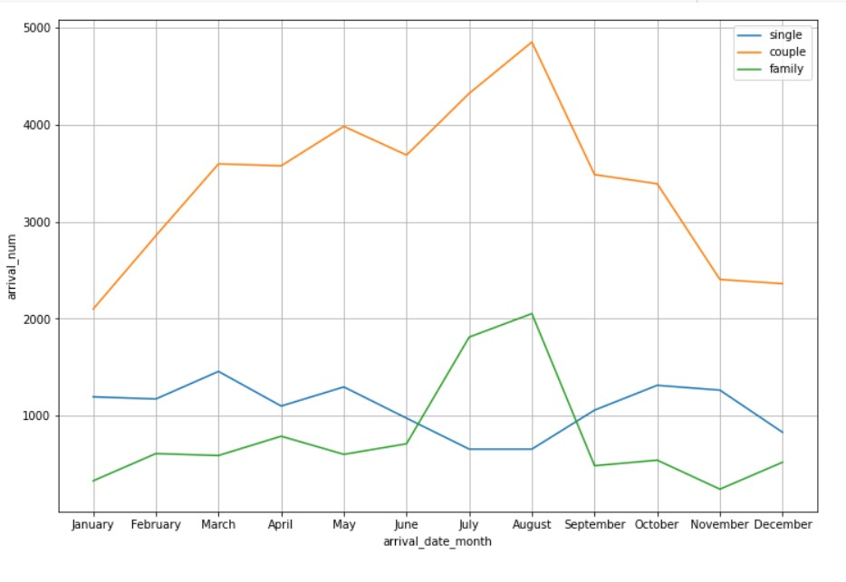

Mostly bookings are done by couples.

It is clear from graph that there is a sudden surge in arrival Num of couples and family in months of July and August. So better plans can be planned accordingly at that time for these types of customers.

### Some important questions

Some other analyses are also done, which are as follows:

1. What is the different reason for special requests
2. What is the optimal stay length for better deal for customers
3. How adr is affected by total staying period in hotels.

### Reasons for special requests

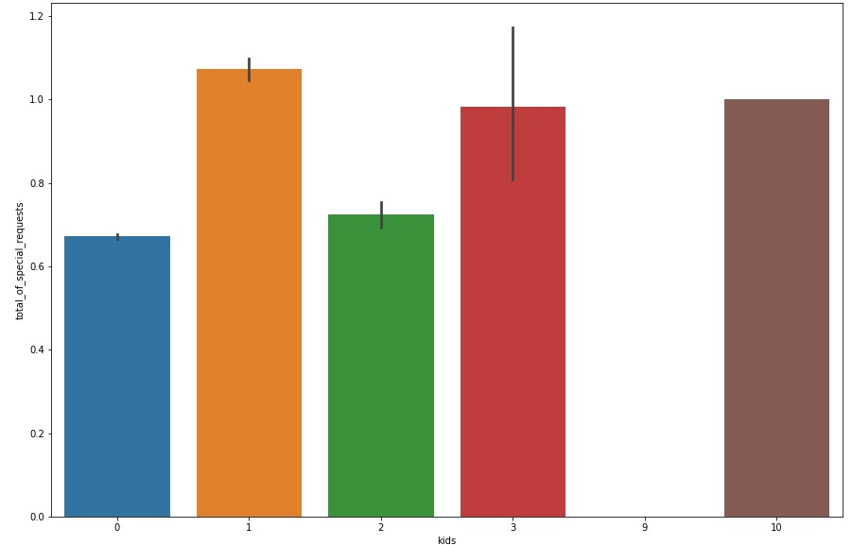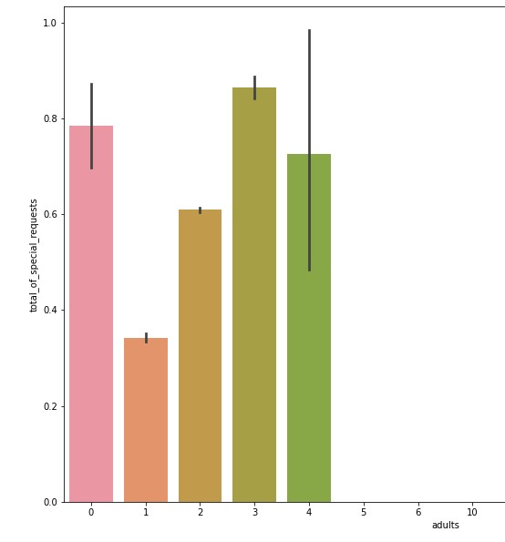

The number of special request are almost the same in the kids section. But, we can see that if the adults are more than 2 there are more chances that hotels will receive more special requests.

### Reasons for special requests(cont.)

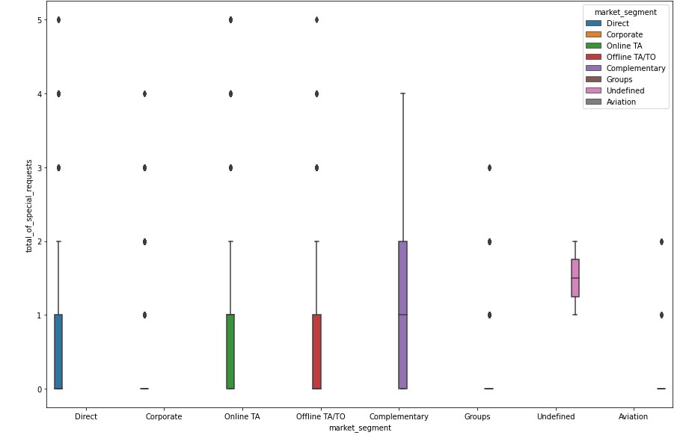

Here we can see that all market segment mostly have special request.

There is one segment which is complementary, having more than average number of special request.

#### Correlation Heatmap

* 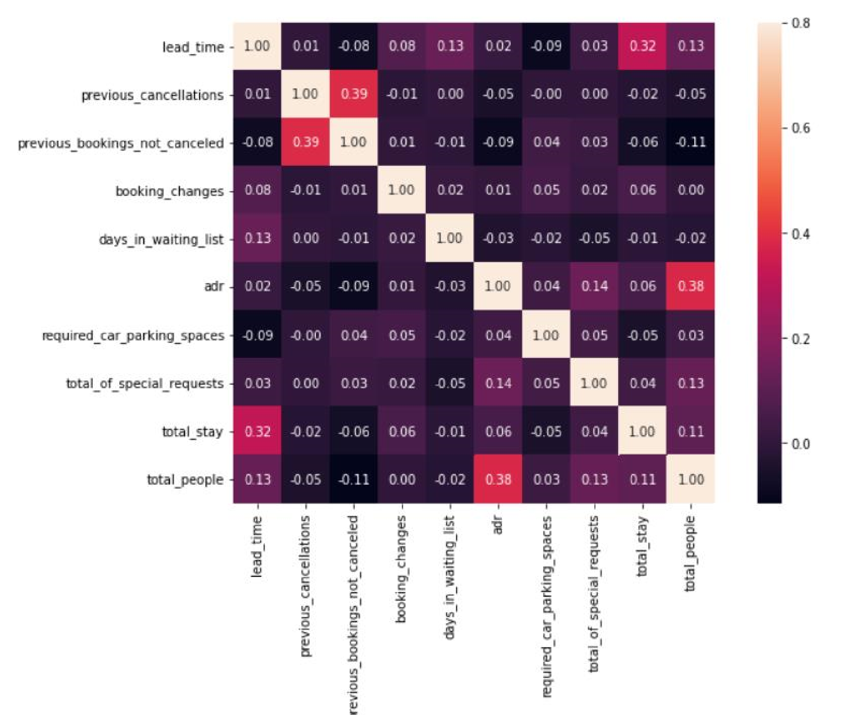Total stay length and lead time are slightly correlated. This may mean that for longer hotel stays, people generally plan little before the actual arrival.
* adr is slightly correlated with total_people, which makes sense as more no. of people means more service to deliver, therefore more adr.

### Optimal stay length for better deals in adr

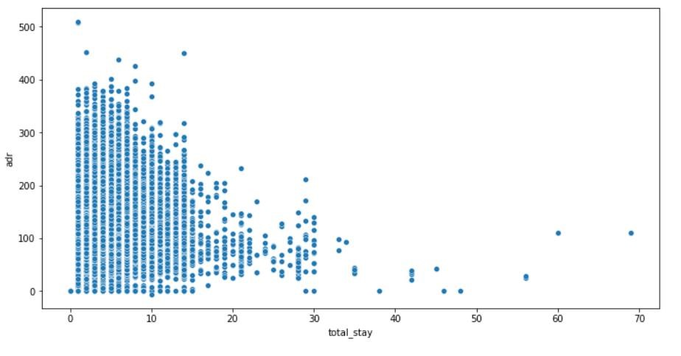

For shorter stays the adr (average daily rate varies greatly) but for longer stays (> 15 days) adr is comparatively very less. Therefore, customers can get better deal for longer stays more than 15 days.

## Conclusion

* Around 60% bookings are for City hotel and 40% bookings are for Resort hotel, therefore City Hotel is busier than Resort hotel. Also, the overall adr of City hotel is slightly higher than Resort hotel.
* Mostly guests stay for less than 5 days in hotel and for longer stays Resort hotel is preferred.
* Both hotels have significantly higher booking cancellation rates and very few guests less than 3 % return for another booking in City hotel. 5% guests return for stay in Resort hotel.
* Most of the guests came from European countries, with most no. of guest coming from Portugal.
* Guests use different channels for making bookings out of which most preferred way is TA/TO.
* For hotels higher adr deals come via GDS channel, so hotels should increase their popularity on this channel.
* Almost 30% of bookings via TA/TO are cancelled.
* Not getting same room as reserved, longer lead time and waiting time do not affect cancellation of bookings. Although different room allotment do lowers the adr.
* July- August are the busier and most profitable months for both of hotels.
* Within a month, adr gradually increases as month ends, with small sudden rise on weekends.
* Couples are the most common guests for hotels; hence hotels can plan services according to couples needs to increase revenue.
* More number of people in guests results in a greater number of special requests.
* Bookings made via complementary market segment and adults have on average high no. of special request.
* For customers, generally the longer stays (more than 15 days) can result in better deals in terms of low adr.

# Thank You